Helpful Hints for printing out to-scale life-sized copies on paper greater than 8 ½" x 14"

This hint works with a HP printer and hopefully will work for another brand.

If you have a PDF file that is large (such as the trackway) and would like to print out an actual copy then you will need to do the following:

1. Go to PRINT command menu for your printer.

2. For this example we choose the “Page Handling” Section.
Under Page Scaling: choose “Tile all pages.”
Tile Scale: 161% (you should see a Composite Preview to the left of that section and it will show you how many pages it will take to print a 1:1 image of the file. In this case it shows 17 x 77 and needing Fourteen 8 ½ x 11 sheets of paper.

To double check that the prints are 1:1, which you will need to use, print out the PDF file of the individual track prints titled “Tracks to Cut Out.pdf.” This file will help you to determine if the scale is right. If the print is too small, just bump up the page scaling number. If too large, then reduce the page scaling number.

Example of Screen:

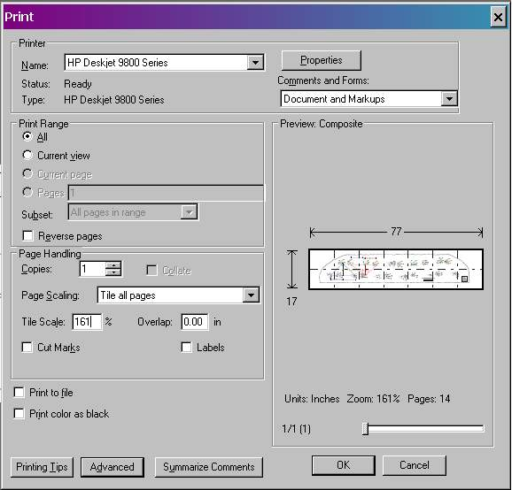

The following files will need to use the above settings to print out 1:1

Footprints millimeter measuring guide.pdf
Tucker 1.pdf & Tucker 2.pdf
Tucker with numbered digits 24x72.pdf

